

**INFORMATICS INSTITUTE OF TECHNOLOGY**

**In Collaboration with**

**UNIVERSITY OF WESTMINSTER**

**Department of Computing**

**(B.Eng.) in Software Engineering**

Module: 6DATA005C.1: Operational Research Optimisation (Individual Report)

**Name : Nethmi Mohotti**

**UoW ID : w1810188**

**IIT ID : 20200486**

**Contents**

1.0 Problem 1

1.1 Problem Domain 1

1.2 Problem Definition 2

1.3 Objectives 2

2.0 Literature Review 3

2.1 Academic Optimization Models 3

2.2 Linear Programming (LP) 3

2.3 Linear Programming Approaches in the Academic Field 4

3.0 Problem Modelling 6

3.1 Time Slots 6

3.2 Module Data 6

3.3 Decision Variables 7

3.4 Objective Function 7

3.5 Constraints 8

3.6 Additional Aspects 10

4.0 Problem Solving 11

4.1 Model Implementation 11

4.2 Experiments 17

4.3 Evidence for the Solution Approach 19

5.0 Evaluation of the Solution 20

6.0 Self-Reflection 21

7.0 References 22

**Table of Figures**

Figure 2.1: Summary of Optimisation Results (Ablan, Bugtai and Billones, 2022) 5

Figure 4.1: Ratings for Module Sections 11

Figure 4.2: Initial Decision Variables 12

Figure 4.3: Sum of Modules and Time Slots 13

Figure 4.4: Constraints for Extra Conditions 14

Figure 4.5:Objective Function Calculation 15

Figure 4.6: Completing the Solver requirements 15

Figure 4.7: Solver Solution 16

Figure 4.8: Optimal Solution for Decision Variables 17

Figure 4.9: Objective Function Result 17

Figure 4.10: Solution with Time Conflicts 18

Figure 4.11: Experimental Model 18

**List of Tables**

Table 3.1: Time Slots Available 6

Table 3.2: Module Data and Rating 7

# Problem

## Problem Domain

The selection of modules for the academic years in the university is one of the critical aspects that the students are assigned in the educational system. This has drawn the attention of the students and the academic staff to aid them in selecting the optimal modules for their preference and many other conditions that are made according to the students and with the university information. Also, with the selection of the modules, the satisfaction of students according to the different types of measurement magnitudes are considered so that the evaluation of the modules with their learning outcomes, the schedule of the lecturers, resource availability, lecturer rating and many other factors(Sutherland, Warwick and Anderson, 2019).

Within the undergraduate curriculum, Student-selected components (SSCs) encourage the greater exploration of core curriculum topics, exploration of optional subjects, research and self-directed learning, and personal and professional development opportunities as of the possibility that was provided for the student to select the path and the modules that they wish to follow to achieve their target (O’Tuathaigh et al., 2012). The case study is contexed around selecting modules for the academic year for Sophie, a third-year undergraduate student majoring in Finance at the University of London. The selection is based on five modules with two mandatory modules, an industry-based module, and two finance-based optional modules. The choice of modules is made according to Sophie’s preference and the priorities set, such as the module's content, the instructor's reputation, and the schedule preferences.

The development of the optimised solution for Sophie’s problem considers the priorities that she has set for the selection of the modules, the rating that she has developed for each of the scheduled times of modules according to constraints and the time constraints according to her commitment to the part-time job that requires her mornings to be accessible for the work. Also, the model is to be created according to the preference of the student, and it should also contain a dynamic nature as the requirements may evolve; therefore, the necessity of creating a model that is flexible for the priorities and possesses the ability to adopt is required through this problem. To summarise, the problem domain comprises the distinct obstacles and factors related to Sophie's module selection procedure, considering the academic framework, rules, and Sophie's personal choices and limitations. This knowledge is necessary to create a customised and efficient optimisation model.

## Problem Definition

The main goal of this case study is to create an optimisation model that helps Sophie, a University of London third-year finance student, choose specific courses for her next academic year. The goal of the model is to optimise Sophie's overall satisfaction with the selected modules while meeting the requirements of the university, which include mandatory core modules and an industry-based module, and taking into account her limitations, like her inability to attend morning classes because of her part-time work obligations.

The specific objectives of the development of the model are to ensure that the core modules Business Strategy (BS101) and International Finance (FIN300) must be selected, an industry-based module should be chosen for Sophie prefers either Business Computing (CS101) or Web Design for Non-profit Organization (CS102) according to her interests, and two out of four finance optional modules from Data Analysis in Finance (FIN315); Risk Management (FIN 316); Options, Futures and Swaps (FIN 317); and Fixed Instruments and Markets (FIN 318). Also, she would like to accommodate Sophie’s part-time job commitment. Also, she has specified some constraints to be considered when selecting classes as to her part-time job; the morning classes should be avoided, and some modules provide two sections to be chosen from that are either to meet once a week for 3hour sessions or to meet twice a week alternating between one-hour and two-hour periods. Also, the rate of the module sections is to be considered; the rate is the weighted average of three factors: the module's content, the instructor and timing are rated according to Sophie’s interest using a scale from 1 to 5, where one is of poor rating, and five means highly interested. The case study aims to develop a mechanism for assessing student happiness based on scheduling preferences, teacher reputation, and content and use it to optimise Sophie's level of contentment with the modules she has chosen.

## Objectives

This section provides an overview of the objectives of this case study.

1. Calculating the optimal solution for the objective function takes the maximised satisfaction value obtained by Sophie.
2. The modules' selection and time sections are validated according to Sophie's preferences and the university's policies.
3. Taking a solution that mainly considers the calculated ratings, taking the weighted mean of the rate given to the module details, the instructor ratings and time section evaluation.

# Literature Review

A student's educational journey is significantly impacted by choosing academic modules, affecting their learning experience, academic achievement, and happiness. University research has turned its attention to integrating optimisation models to improve the efficacy and efficiency of module selection procedures. With an emphasis on the case of Sophie, a third-year finance student at the University of London struggling with the problematic module selection process, this literature review explores previous research on optimisation models in the context of student module selection.

## Academic Optimization Models

Numerous investigations have examined optimisation models in educational environments to streamline decision-making procedures and enhance resource distribution. In a university context, course scheduling involves several operational choices. The courses remain mostly the same from year to year, but the universities still have to choose which instructors will teach each class and during which term. The university then has to decide when and where to provide each course based on the course lists for that specific term. Students are allowed to register for classes when a timetable is set. An ideal schedule should enable students to attend all the lessons they choose to take or need to take without any conflicts. Cases such as course scheduling are discussed more often because of their complexity, scale and various application-specific information (Barnhart et al., 2021).

Regarding university course scheduling, methods typically balance a post-enrolment perspective that considers individual students' interests and a curriculum-based perspective that maintains that courses that must be taken in sequence cannot be offered at inconvenient times. A large amount of processing power is needed to model each student individually, and a data management system is required to manage student data. This is why early efforts in room assignment and course scheduling, instead of using the more controllable curriculum-based approach, concentrated on developing optimization-based algorithms (Bettinelli et al., 2015). In the case of student enrolment, the models explicitly require metaheuristics because accurate optimisation procedures usually do not scale and need additional pre- and post-processing of the results (Ceschia, Di Gaspero and Schaerf, 2014). Following that, many optimisation formulations use integer programming and linear programming solvers to obtain high-quality solutions for the timetabling approaches.

## Linear Programming (LP)

While linear programming has numerous applications, one of its original uses dates back to World War II when it became more necessary to address logistical and resource allocation issues; in addition, the 1975 Nobel Prize in Economics went to an economist and a mathematician for their work on the theory of optimum resource allocation, which mainly used linear programming. Since then, a broad range of industries have used linear programming to resolve problems related to logistics and resource allocation, such as determining how best to allocate a finite number of resources (Galindo et al., 2021).

Linear programming is a mathematical technique that finds the best way to distribute scarce resources among conflicting demands while maintaining optimality. It addresses the challenge of establishing the optimal allocation of scarce resources to achieve a given aim. Optimisation issues involving a linear objective function and all linear constraints regarding choice variables are called linear programming problems. The goal of an optimisation task is to reduce a linear cost function. This goal makes it feasible to consider the satisfaction of stated preferences in various contexts, including production and planning, academic research, manufacturing concerns, and other fields (Galindo et al., 2021).

To determine the ideal operating conditions for the chiller plant while taking into account the specific functioning of the chillers, cooling tower, and air handling units for an academic building, Zulkaflia et al. (2022) employ a linear programming model for the Chiller network. The ideal operation of the chiller plant in an academic building has been provided by considering the functioning of chillers, cooling towers, and air handling units. The findings show that the perfect cost as a percentage is around 23% lower than the present cost. This illustrates how the building owner may directly improve the rate of energy used to achieve reduced electricity costs and increased energy efficiency by optimising the chiller plant's energy usage. As a result, this may lead to an academic building receiving a high Energy Star rating to implement sustainable energy practices.

Time management is essential to approach tasks with a positive mindset. Effective time management in the classroom is vital for college students to succeed in their studies. Students typically blame their concerns about not having enough working time on the number of assigned assignments. They will participate in classes, projects, tasks, and tests throughout their academic stay. They cannot plan systematically for the completion of their chores if they cannot manage how much time they spend on things. Students may utilise LP to optimise their operations while scheduling academic courses, work, maintenance intervals, and other activities. This allows them to manage their time effectively and allocate time for all planned requirements. These enable firms to control expenditures, expenses, and time management while maximising or decreasing student resources (Ablan, Bugtai and Billones, 2022).

## Linear Programming Approaches in the Academic Field

The academic sector is a vital field worldwide; operational researchers may model the systems in several ways by taking its perspective and give managers, planners, and policymakers insightful projections. In education, optimisation is applied in various contexts, including transportation routing and scheduling, course and test scheduling, student course assignments, and student work assignments in groups. In the academic field, many transportation problems consider routing problems to find the shortest distance and scheduling models to include the time constraints for the travel duration (Johnes, 2015).

In online learning, optimising academic working length is critical to balance a student's personal and educational obligations appropriately. They can allocate a lot of time for academics by taking on a limited academic load for the semester and cutting down on time spent on other activities. Ablan, Bugtai and Billones (2022) forward an optimisation model calculated using MATLAB using linear programming to obtain a minimisation and maximisation applied to the objective function to evaluate the time allocated for academic class, leisure time, household responsibilities and sleep time. Based on the results, students often dedicate three hours a day to studying, which is how they spend their time. This indicates that 15 hours a week are used for academic activity. It is recognised that this is a distribution of 10 to 20 hours for academic work in a week as it comes inside the survey's choice of managing time for studying between 2 to 4 hours. Consequently, the LP minimisation case's maximal working hours exceed the students' survey results by 29 hours. One may assess that there would be plenty of time for children to complete their academic assignments.

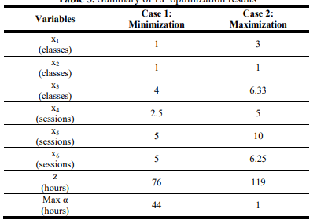

Figure 2.1: Summary of Optimisation Results (Ablan, Bugtai and Billones, 2022)

# Problem Modelling

The case study is handled with linear programming as it is a model that should be developed to create a selection model to choose the third-year modules for Sophie. The model's objective is to maximise the satisfaction of Sophie while adhering to the university's requirements and accommodating her constraints.

## Time Slots

The time slots for the modules were selected according to Sophie’s choice.

|  |  |  |  |  |
| --- | --- | --- | --- | --- |
| **Mon** | **Tue** | **Wed** | **Thu** | **Fri** |
| 1.25 - 2.20 (M1) | 1.25 - 3.15 (T1) | 1.25 - 3.15 (W1) | 1.25 - 2.20 (Th1) |  |
| 1.25 - 3.15 (M2) |  | 1.25 - 2.30 (W2) | 2.20 - 5.15 (Th2) |  |
| 6 - 8.45 (M3) | 6 - 8.45 (T2) | 2.30 - 5.15 (W3) | 6 - 8:45 (Th3) | 6 - 8.45 (F1) |
|  |  | 6 - 8.45 (W4) |  |  |

Table 3.1: Time Slots Available

## Module Data

The data given in the case study was summarised according to the time slots and the rating specified.

|  |  |  |  |  |
| --- | --- | --- | --- | --- |
|  | **Module** | **Section** | **Rating** |  |
| 1 | BS101 | M3 | 4.3 | R1 |
| 2 | BS101 | T2 | 3.8 | R2 |
| 3 | BS101 | W4 | 3.5 | R3 |
| 4 | BS101 | F1 | 3.5 | R4 |
| 5 | BS101 | M1 | 4.6 | R5 |
| 6 |  | W1 | 4.6 | R5 |
| 7 | BS101 | T1 | 2.7 | R6 |
| 8 |  | Th1 | 2.7 | R6 |
|  |  |  |  |  |
| 9 | FIN300 | W4 | 3.5 | R7 |
| 10 | FIN300 | T1 | 3.3 | R8 |
| 11 |  | Th1 | 3.3 | R8 |
|  |  |  |  |  |
| 12 | CS101 | W3 | 4.4 | R9 |
| 13 | CS101 | Th2 | 3.1 | R10 |
|  |  |  |  |  |
| 14 | CS102 | T2 | 3.7 | R11 |
| 15 | CS102 | W3 | 3.5 | R12 |
|  |  |  |  |  |
| 16 | FIN315 | Th3 | 3 | R13 |
| 17 | FIN315 | M1 | 3.7 | R14 |
| 18 |  | W1 | 3.7 | R14 |
|  |  |  |  |  |
| 19 | FIN 316 | M3 | 3.6 | R15 |
| 20 | FIN 316 | M2 | 3.9 | R16 |
| 21 |  | W2 | 3.9 | R16 |
|  |  |  |  |  |
| 22 | FIN 317 | T2 | 3.2 | R17 |
| 23 | FIN 317 | T1 | 3.4 | R18 |
| 24 |  | Th1 | 3.4 | R18 |

Table 3.2: Module Data and Rating

## Decision Variables

Let 🡪 for every module section $i$ and $j$ are decision variables where:

$x_{ij}=1$ (if module is selected)

$x_{ij}=0$ (if not)

## Objective Function

The model's objective function is a maximising function that maximises the overall satisfaction of the selected modules. This expression is made by multiplying the rating of each module section with the decision variable of either **1** or **0**, the maximum value of the sum of the product of these two values, which is taken as the objective function.

Maximise: $Z= \sum_{i=1}^{n}{\sum_{j=1}^{n}{{Rating}_{ij}x_{ij}}}$

$Z = R1x_{BS101,1} + R2x_{BS101,2}+R3x_{BS101,3}+R4x_{BS101,4}+R5x_{BS101,5}+R6x_{BS101,7} + R7x_{FIN300,9} + R8x_{FIN300,10} + R9x_{CS101,12}+R10x_{CS101,13} + R11x_{CS102,14 }+ R12x_{CS102,15} + R13x_{FIN315,16} + R14x_{FIN315,17} + R15x_{FIN316,19} + R16x_{FIN316,20} + R17x_{FIN317,22} + R18x_{FIN317,23} + R19x_{FIN318,25} + R20x_{FIN318,26 }$

## Constraints

When creating the model, many constraints are considered, including the requirements of Sophie and the university policies and regulations enforced on a third-year undergraduate.

Following are the constraints that are considered in the development of the optimal solution for the problem:

1. Mandatory Module

One module section of the mandatory modules BS101 and FIN300 must be selected. That is, out of all the time sections given to these compulsory modules, a one-time slot, either 3 hours or a combination slot alternating between 1 and 2 hours, must be selected.

2. Industry-based Module

It is mentioned that many of the industry-based modules are provided by the School of Computer Science, in which Sophie has selected two modules she finds enjoyable as, CS101 and CS102, in which she is choose one module.

3. Finance Modules

Of the four finance modules selected according to their potential, Sophie must choose two modules out of FIN315, FIN316, FIN317, and FIN318. In which are providing the highest satisfaction rates for Sophie.

4. Avoiding Morning Classes

A significant requirement Sophie mentioned is for her part-time job, that require her to work in the mornings; the schedules are selected so that the morning classes will be avoided.

$$\sum_{i=1}^{n}{\sum_{j=1}^{n}{y_{ij}x_{ij}}}=0$$

5 Selection from Multiple Modules

In cases such as selecting one module from the two Industrial-based modules or selecting two out of the four Optional finance modules the each of the different modules also carry different timeslots; the constrains are made so that from one module, one time section either of three hours or combination is to be selected following the module selection denies for different options.

Industrial Modules

$$\sum_{i=1}^{n}{x_{CS101,i}}≤1$$

$$\sum_{i=1}^{n}{x_{CS102,i}}≤1$$

Finance Optional Modules

6. Schedule Sections with Combination Sections

For the selection of combination time slots that alternate between 2 hours and 1 hour time slots instead of complete 3-hour times, the other place must be chosen when selecting either time slots of the combination. Therefore, the constraint for this requirement is created as the difference between the decision variables of the time slots of the combination must give zero.

7. Selection of Modules Considering Time Constraints

Wednesday, three time slots will be conflicting. If Sophie attends Wednesday, 1.25-3:15 pm (W1), she will not be able to participate in both the 1.25-2.20 pm (W2) and 3.30 – 5.15 pm(W3) time slots. But if she is to attend the W2 time slot, she could follow the W3 sections as well without any time conflicts.

$$x_{BIS101,6}+x_{FIN315,18}+ x_{CS101,12}+ x_{CS102,15}≤1$$

$$x_{BIS101,,6}+x_{FIN315,18}+ x_{FIN316,20}≤1$$

## Additional Aspects

The ${Rating}_{ij}$ of the module section is obtained by the calculation of weighted mean of the ratings that Sophie has provided as:

* Content of the Module
* Ratings of the instructor's reputation
* Timing rating

All are rated from 1 to 5, with 1 being the poor interest and 5 being the excellent interest. So, we can assume that the rating is calculated by taking $W_{content}, W_{instructor}, W_{time}$ as the weighting factors.

$${Rating}_{ij}= \frac{{Content}_{ij} W_{Content}+ {Instructor}_{ij} W_{Instructor}+ {Time}_{ij} W_{Time}}{W_{Content}+W_{Instructor}+W_{Time}}$$

# Problem Solving

## Model Implementation

The following gives the steps for creating the model to get the maximum value for the objective function with the constraints used.

Step 1: Adding the rating to the module sections.

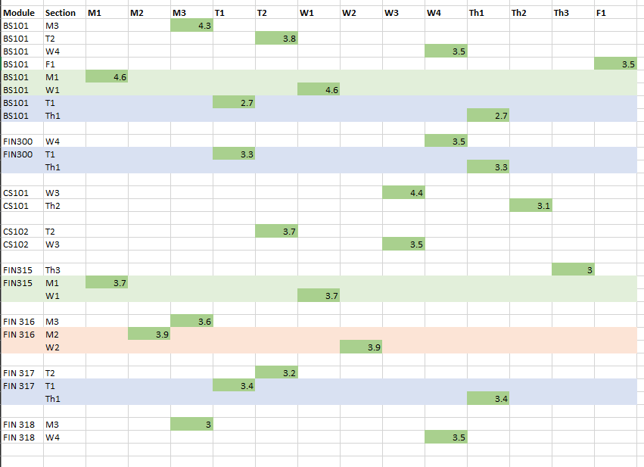The model is created in Excel. The rating is initially added to different module time schedules, as given below, considering the module data information for the time section.

Figure 4.1: Ratings for Module Sections

Step 2: Adding the objective variables to the time slots

The decision variables for the specific module section are initially added as $0$**.** As the decision variables are either 0/1 with the model is added into the solver, the decision variables that are changed originally according to the constraints mentioned and according to the selection of the modules (decision variables getting 1), the objective function is calculated to get the maximum module selection rate.

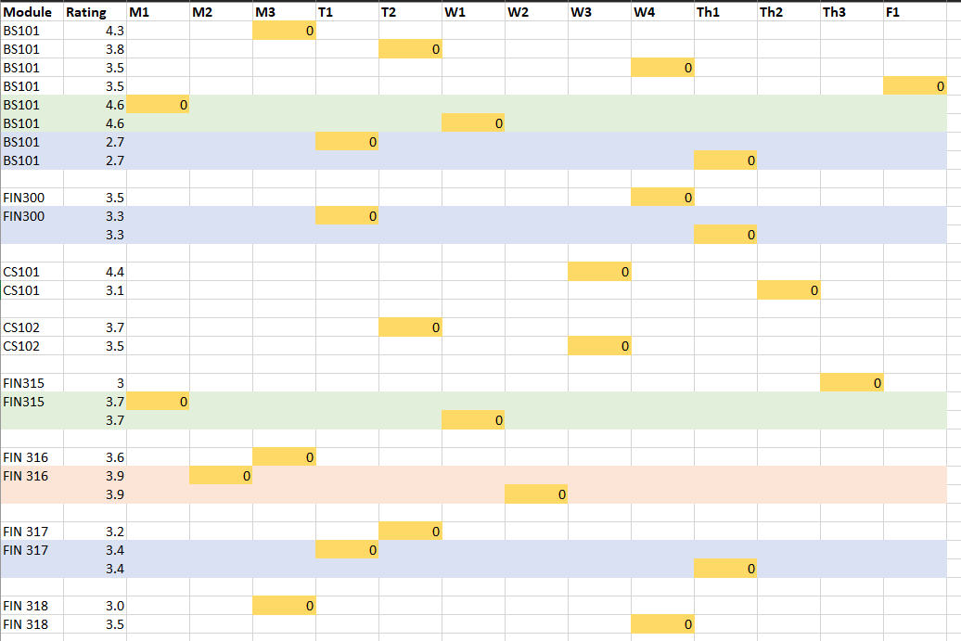

Figure 4.2: Initial Decision Variables

Step 3: Take the Sum of Modules and Times Slots

The sum of the modules as following are taken:

1. The sum of all the core modules sections must equal 1.
   1. One-time slot should be chosen for BS101 (3 hours or combination)
   2. One-time slot must be chosen for FIN300 (3 hours or combination)
2. The sum of the industrial-based module section must equal to 1.
   1. One of either CS101 or CS102 should be selected.
   2. The sum of each module should be less than or equal to one. (e.g., if CS101 is chosen, the sum of CS101 is 1, then the sum of CS102 must be 0)
3. The sum of the optional finance module must equal to 2.
   1. Two of the four modules that are chosen must be selected.
   2. The sum of each module should be less than or equal to 1. (e.g., if FIN316,317 is chosen, the sum of each module is 1, and the rest of modules (FIN315 & FIN318) sum should be zero)
   3. One-time slot for each module should be chosen from the chosen modules. (e.g., if FIN316 is chosen, there are two slots to choose from, either a 3-hour slot or a combination slot; therefore, the sum of the time slot must be equal to 1, but considering if it was not changed the constrain should be as the sum of the module chosen is less than or equal to 1).

Also, the sum of each time slot can be chosen only once or not as all; therefore, the sum of each time slot is less than or equal to 1.

Figure 4.3: Sum of Modules and Time Slots

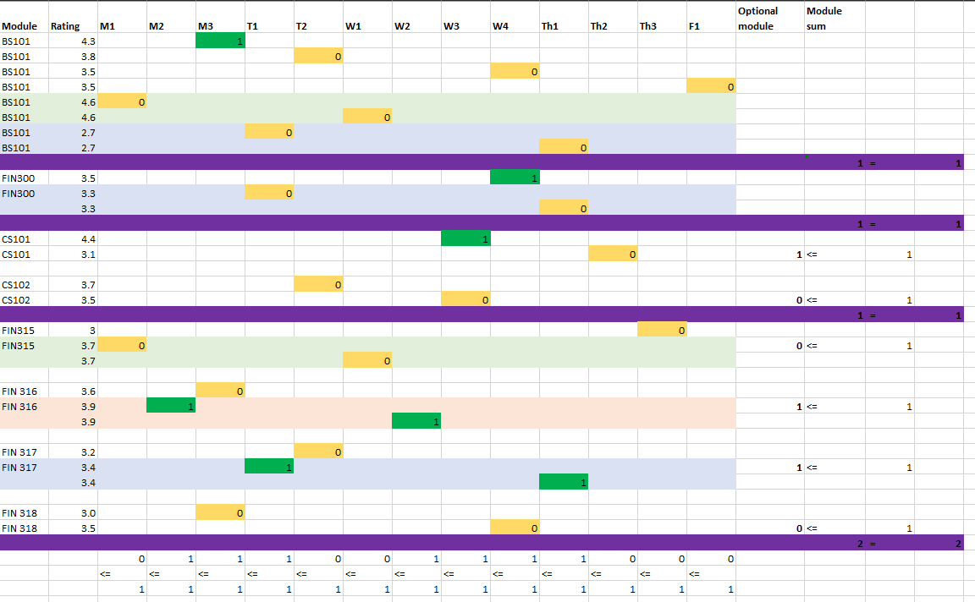

Step 4: Considering the Extra Constraints

Two sets of extra constraints are considered with the selection as mentioned above constraints:

1. Difference in Combination time is equal to zero.
   1. That is, when one slot of the combination time section alternates between 1 and 2 hours, the other slot is automatically selected. This is considered as the difference between the 2-objective variables is zero.
2. The time conflicting constraints are less than or equal to zero.
   1. If the Wednesday W1 time slot is chosen, Sophie cannot attend the W2 time slot, for the difference between the sum of two decision variables should be less than or equal to zero.
   2. If the Wednesday W1 time slot is chosen, Sophie cannot attend the W3 time slot, for the difference between the sum of two decision variables should be less than or equal to zero.

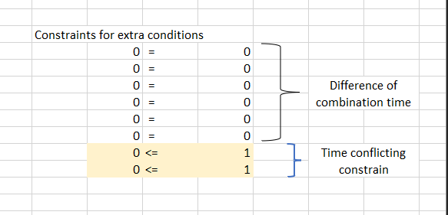

Figure 4.4: Constraints for Extra Conditions

Step 5: Calculating the objective function

The objective function, which is the sum of the product of the ratings with the decision variables, is taken into consideration.

$Max Z=4.3*E2+3.8*G3+3.5*K4+3.5*O5+4.6*C6+2.7*F8+3.5*K11+3.3*F12+4.4*J15+3.1*M16+3.7*G18+3.5*J18+3*N21+3.7*C22+3.6*E25+3.9*D26+3.2*H29+3.4*F30+3*E33+3.5*K34$

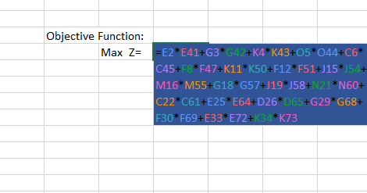

Figure 4.5:Objective Function Calculation

Step 6: Applying the Solver

The solver popup is taken into using the solver tool. The optimal value of the objective function could be taken by changing the values in the variables cells with the constrains being used to optimized the solution according to the requirement.

The constrains that are calculated, the objective function to maximize that was calculated and the decision variables are added to their specific positions so that the model could be solved to take the optimal solution.

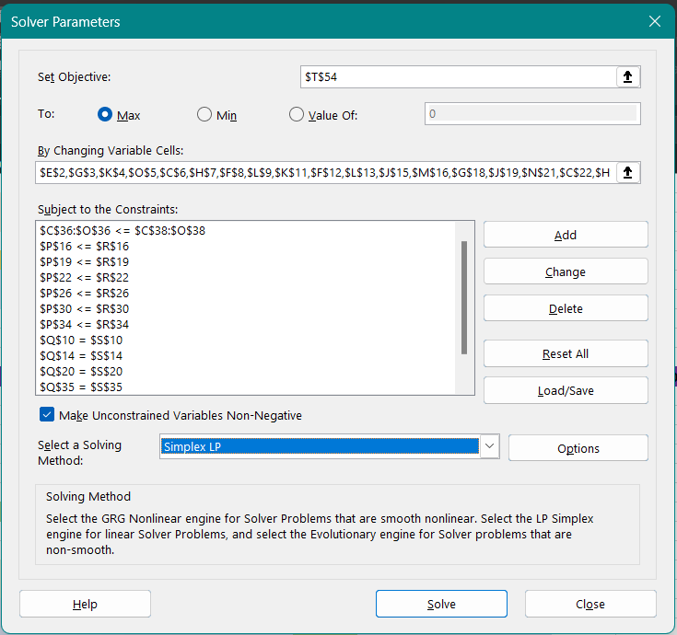

Figure 4.6: Completing the Solver requirements



Figure 4.7: Solver Solution

Step 7: Obtain the Final Solution

The solution is obtained so that the optimal module sections that Sophie should attend according to the constraints specified to take the maximum objective function value are as follows.

The following time slots and modules are chosen from the optimal solution given by the solver:

* Core Modules
  + BS101 🡪 Monday 6:00 – 8:45 pm (M3)
    - Rating = 4.4
  + FIN300 🡪 Wednesday 6:00 – 8:45 pm (W4)
    - Rating = 3.5
* Industrial-based Modules
  + CS101 🡪 2.30 – 5:15 pm (W3)
    - Rating = 4.4
* Finance Optional Modules
  + FIN316 🡪 Monday 1:25 – 2:20 pm and Wednesday 1:25 – 3:15 pm (M1 & W1)
    - Rating = 3.9
  + Fin 317 🡪 Tuesday 1:25 – 3:15 pm and Thursday 1:25 – 2:20 pm (T1 & Th1)
    - Rating = 3.4

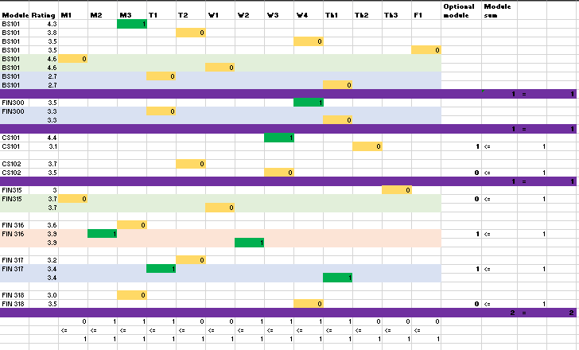

Figure 4.8: Optimal Solution for Decision Variables

The maximum of the objective function is calculated as 19.5 by the solver.

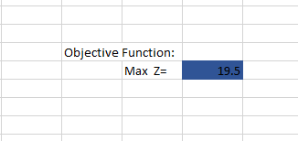

Figure 4.9: Objective Function Result

## Experiments

When making the constraints, many experimental answers were obtained as some of the solutions gave different answers with many changes. One of the significant experimental handlings was to get the time conflict change as in one of the experimental handling the time constrains was not handles the optimal salutation gives a comparatively high value but for Wednesday the time all the time slots W1, W2, and W3 are all chosen and Sophie would not be able to attend to both W2 and W3 if she is chosen W1. This issue was resolved for the final solution.

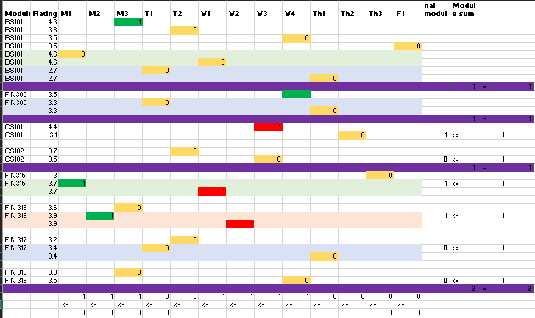

Figure 4.10: Solution with Time Conflicts

Also, in the development phase of the model two models were finalized in which one considered the combination times as a one time slot and taken the maximized objective function and with the same optimization provided but this was only considered as evidence that the model could be developed taking the time combinations that are alternating between two days could be taken as one time slot and still the model was able to provide the equal optimization and as well as the time slots.

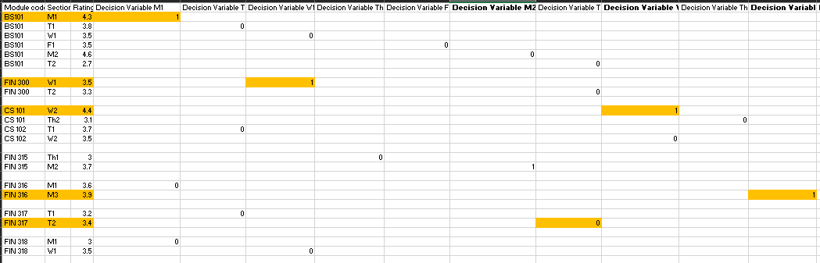

Figure 4.11: Experimental Model

## Evidence for the Solution Approach

The problem was formulated according to Sophie's requirements: a selection problem and a complex assignment problem. The model is formulated using the linear programming approach to articulate the decision variables, objective function, and constraints based on university policies and Sophie's requirements and preferences.

The decision variables are of a binary nature. That is, the module section could be selected accordingly or not be selected. The calculation of this expression involves taking the sum of the products of the rates of each decision variable with their value either of 1 or 0. Correspondingly, the constraints are defined to ensure that the selection of modules for Sophie adheres to the university rules, preferences and requirements of Sophie. Here, the core module section selection, the industry-based module selection with the sections and the finance optional module and section selection have been considered. It is assumed that as there are no morning classes for the options provided, no morning module section will be selected for the solution.

Linear programming modelling was taken as the suitable implementation model for this optimisation task, and the Solver tool in Excel was utilised to formulate the problem. Sensitivity analysis was done to evaluate the solution's robustness. This required assessing how adjustments to restrictions, coefficients, or other factors impacted the best solution. Sensitivity analysis shed light on possible differences in Sophie's module selection as well as the stability of the model.

Model could be obtained from 🡪 [Model](https://docs.google.com/spreadsheets/d/1GW-cRwccRoIocyCpU6-Jb-XCn9LbgcIU/edit?usp=sharing&ouid=109057313270033579566&rtpof=true&sd=true)

# Evaluation of the Solution

The solution given to Sophie is made considering the university regulations on choosing the modules for third-year student finance majors in the University of London. The solution also considers the requirements specified by the student and according to the modules she finds interesting for the optional choices. Therefore, the solution is provided in a way that the modules and the sections are made not only according to the university regulations but also considering the preference ratings that are given to each module and time slots according to the weighted means taken into consideration from the individual ratings given to the content of the module, the instructor rating and the time slot.

Through this, it could be decided that the solution obtained by the model aligns with the priorities, therefore concluding the model's effectiveness as it could be overviewed that many of the highest rating module sections are chosen for the time slots to be attended. The solution that emerges from a successful optimisation should be near the theoretical maximum. The current linear programming model obtains a maximum rate of 19.5, the maximum satisfaction level for Sophie adhering to the regulated constraints. Also, the computational efficiency is obtained as the optimisation process does not require a long time to generate the solution.

The practicability of the model could be taken as good as the module availability and logistical considerations are considered; also, the scheduling conflicts are minimised with the constraints developed. It is confirmed that other students could use the model by changing the ratings and the optional modules to prove that the model could be adapted to the requirements of the specific students who want to select the models for their university requirements. Similarly, the model could be adopted according to the changes in preference of Sophie over time and the flexibility of the model could be assess over the iterative use of the model.

# Self-Reflection

The main objective of the case is to find the maximum satisfaction value for the objective variable, taking into account that rating and the specified requirements. The assignment requires studying the case study provided as a team and developing an optimisation model for this module selection problem, which could be considered a complex assignment problem. It is required to decide as a group the problem that should be resolved and the details to specify when starting to develop a model. Therefore, the decision variables to be used are specified initially, and the model details to have the time schedules defined and the combination points are specified initially.

The primary constraints, such as module selection and the objective function, were developed as a group. Each member was requested to optimise the model further individually, adding the necessary constraints per their requirements and understanding of the case study. After developing the models, two models are selected out of the modes that provide optimal solutions to get the maximum satisfaction as the objective function. Then, the models that require some evaluation and optimisation were discussed for them to get the optimised result. The two designed models were of similar behaviour, but one carries some assumptions that the other has taken in as constraints. The sections, such as the combination time slots, were not considered one. Still, as two separate decision variables and when selecting a combination, if one of the decision variables of the combination is selected, then the other variable must be as 1. In Which a constraint is created to provide that the difference between the two decision variables of the constraint must be zero. Each member could develop their own model through this method, but we all created the same model as a group.

Many experimental answers were developed, but when the discussion is being made, each of the issues and answers of different models could be taken into one. This provided all of the group members with an opportunity to experience the development of the model. Also, they could discuss and learn about the modelling process through linear programming. It also paves each member a path to track down errors of constrains and human errors, which is a well-known method of learning further regarding unclear areas. Also, during the presentation, each of us divided the significant topics mentioned in the specifications as the problem description, problem modelling, problem-solving, and solution interpretation. I have contributed to the problem-solving component as well as the modelling component.

Through this project many advantages were obtained by each team member, the most important being it provided each of us with an opportunity to work as a group to solve a case study that was provided and we were able to go through so many development models in linear programming, networking and also integer programming to get to the final solution for the problem identified. And also, personally, for me, I was given an opportunity to get exposure to working as a group leader. Through this coursework the time management skills, team working skills, it provided all of us with the exposure to the techniques in which we could solve a problem in a case study.

# References

Ablan, L.X.J., Bugtai, N.T. and Billones, R.K.C. (2022). Optimization and Time Management of Weekly Class Schedule with Activity Constraints for College Students using Linear Programming. *2022 IEEE 14th International Conference on Humanoid, Nanotechnology, Information Technology, Communication and Control, Environment, and Management, HNICEM 2022*. Available from https://doi.org/10.1109/HNICEM57413.2022.10109374 [Accessed 3 December 2023].

Barnhart, C. et al. (2021). Course Scheduling Under Sudden Scarcity: Applications to Pandemic Planning. *Manufacturing & Service Operations Management*, 24 (2), 727–745. Available from https://doi.org/10.1287/MSOM.2021.0996 [Accessed 3 December 2023].

Bettinelli, A. et al. (2015). An overview of curriculum-based course timetabling. *TOP*, 23 (2), 313–349. Available from https://doi.org/10.1007/S11750-015-0366-Z/TABLES/3 [Accessed 3 December 2023].

Ceschia, S., Di Gaspero, L. and Schaerf, A. (2014). The generalized balanced academic curriculum problem with heterogeneous classes. *Annals of Operations Research*, 218 (1), 147–163. Available from https://doi.org/10.1007/S10479-013-1358-8/TABLES/6 [Accessed 3 December 2023].

Galindo, A.M.O. et al. (2021). Cost Optimization for the Allocation, Production, and Distribution of a Plastic Manufacturing Company Using Integer Linear Programming. *2021 IEEE 13th International Conference on Humanoid, Nanotechnology, Information Technology, Communication and Control, Environment, and Management, HNICEM 2021*. Available from https://doi.org/10.1109/HNICEM54116.2021.9731804 [Accessed 3 December 2023].

Johnes, J. (2015). Operational Research in education. *European Journal of Operational Research*, 243 (3), 683–696. Available from https://doi.org/10.1016/J.EJOR.2014.10.043 [Accessed 3 December 2023].

O’Tuathaigh, C.M.P. et al. (2012). Selection of student-selected component [SSCs] modules across the medical undergraduate curriculum: Relationship with motivational factors. *Medical Teacher*, 34 (10), 813–820. Available from https://doi.org/10.3109/0142159X.2012.701025 [Accessed 1 December 2023].

Sutherland, D., Warwick, P. and Anderson, J. (2019). What factors influence student satisfaction with module quality? A comparative analysis in a UK business school context. *The International Journal of Management Education*, 17 (3), 100312. Available from https://doi.org/10.1016/J.IJME.2019.100312 [Accessed 1 December 2023].

Zulkaflia, N.I. et al. (2022). Optimal Operation of Chillers Plant in Academic Building by using Linear Programming Approach.